Name:- Saiba pathan
Roll_no:- 09
Div:- C

Lab – 02
Title: CI/CD Pipeline for a Web App using AWS CodePipeline and CodeBuild.

Objective:
To set up a complete Continuous Integration and Continuous Deployment (CI/CD) pipeline using AWS CodePipeline, CodeBuild, and GitHub as the source code repository. This lab demonstrates automation from code commit to build and optional deployment.

Duration:
Approximate time taken to complete the lab: 2 Hours

Pre-requisites:
• AWS Free Tier account
• Access to AWS services: CodePipeline, CodeBuild, IAM, S3
• GitHub account with a sample HTML/static web app
• GitHub Personal Access Token (PAT)
• Basic Git and terminal knowledge

Lab Steps:
Part A – Setup (GitHub)

- Launch AWS CloudShell
- Open: https://console.aws.amazon.com/cloudshell
- Region: Use us-east-1 or another CodePipeline-supported region

- Clone a Sample Web App
- cd ~/
- git clone https://github.com/YOUR_USERNAME/sample-web-app.git
- cd sample-web-app

- Push App to GitHub
- git remote set-url origin https://github.com/YOUR_USERNAME/sample-web-app.git
- git push origin main

- Create S3 Bucket for Artifacts
- aws s3 mb s3://your-cicd-artifacts-<your-id>

📸Screenshot 1: GitHub repo showing index.html uploaded
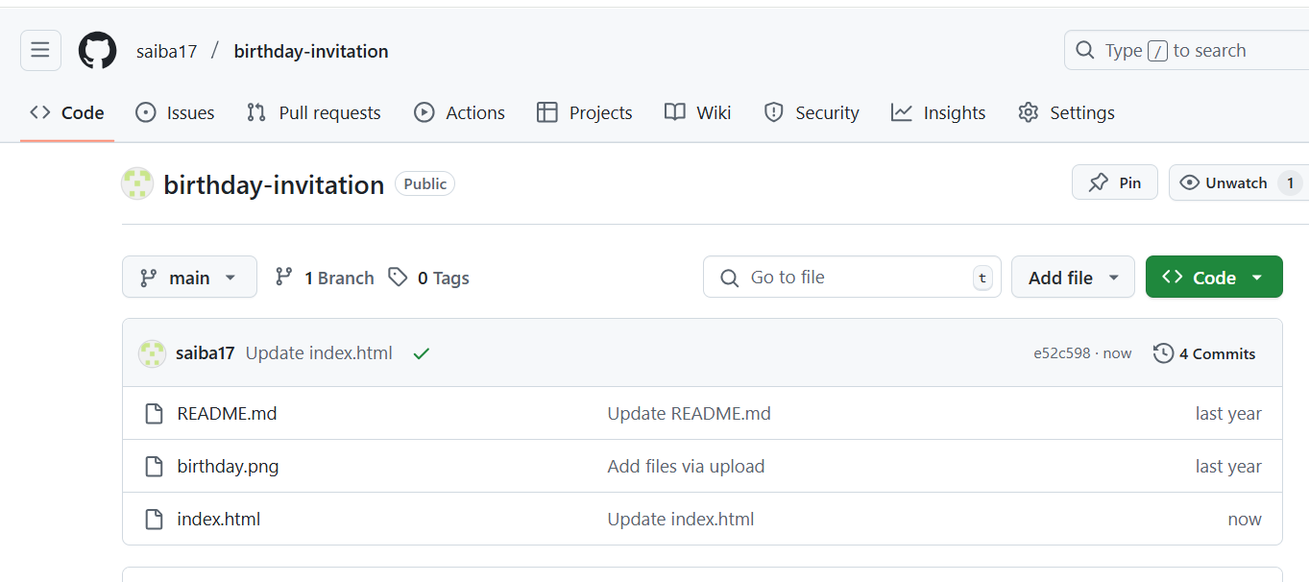

Part B – IAM Role Setup
- Create IAM Role for CodeBuild
• Go to IAM → Create Role → AWS service → CodeBuild
• Attach policies:
- AmazonS3FullAccess
- CloudWatchLogsFullAccess
- AmazonEC2ContainerRegistryReadOnly
Name: CodeBuildServiceRole
- 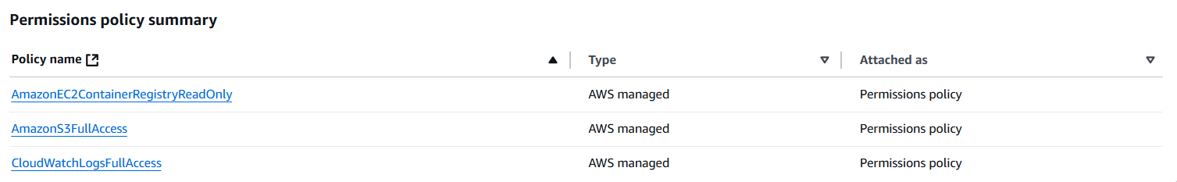
- Create IAM Role for CodePipeline
Service: AWS → CodePipeline
Attach policies:
- AWSCodePipelineFullAccess
- AmazonS3FullAccess
Name: CodePipelineServiceRole
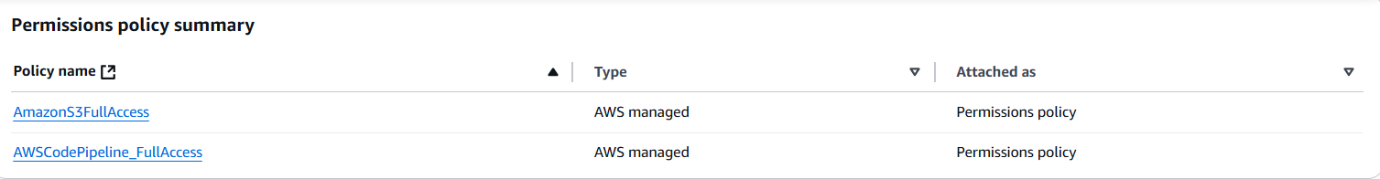
📸Screenshot 2: S3 bucket static hosting settings
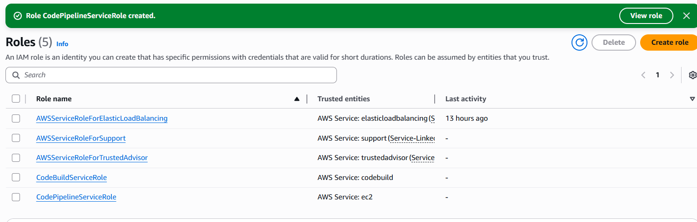
Part C – CodeBuild Project Setup
- Add buildspec.yml file
echo "version: 0.2
phases:
build:
commands:
- echo Build started
- echo Build complete
artifacts:
files:
- '**/*'" > buildspec.yml
git add buildspec.yml
git commit -m "Add buildspec for CodeBuild"
git push
- Create CodeBuild Project
• Go to AWS → CodeBuild → Create project
• Project name: SampleWebAppBuild
• Source: GitHub (via PAT or OAuth)
• Environment: Amazon Linux
• Role: CodeBuildServiceRole
• Buildspec: Use file from source
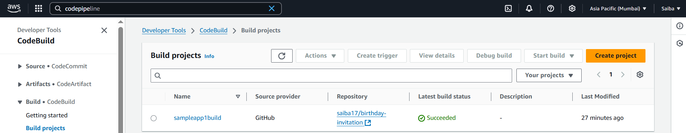
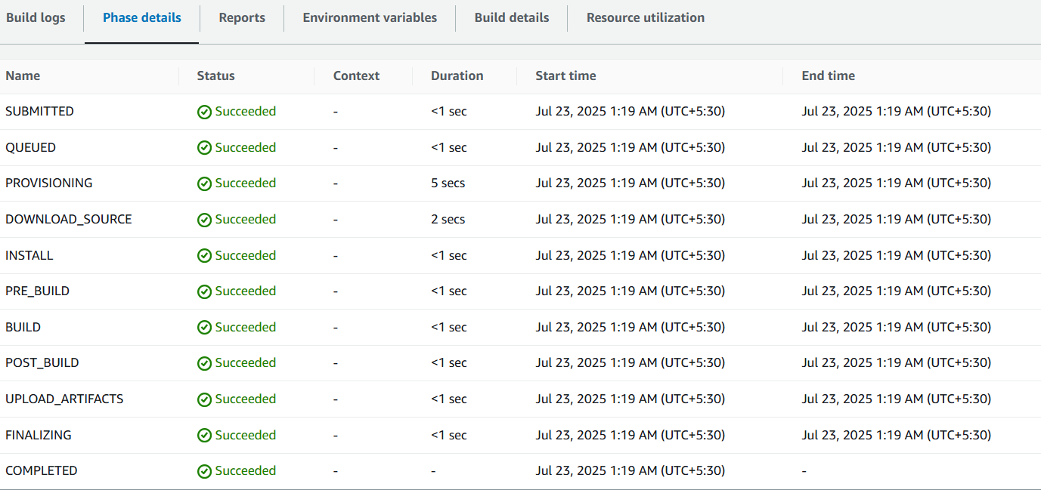

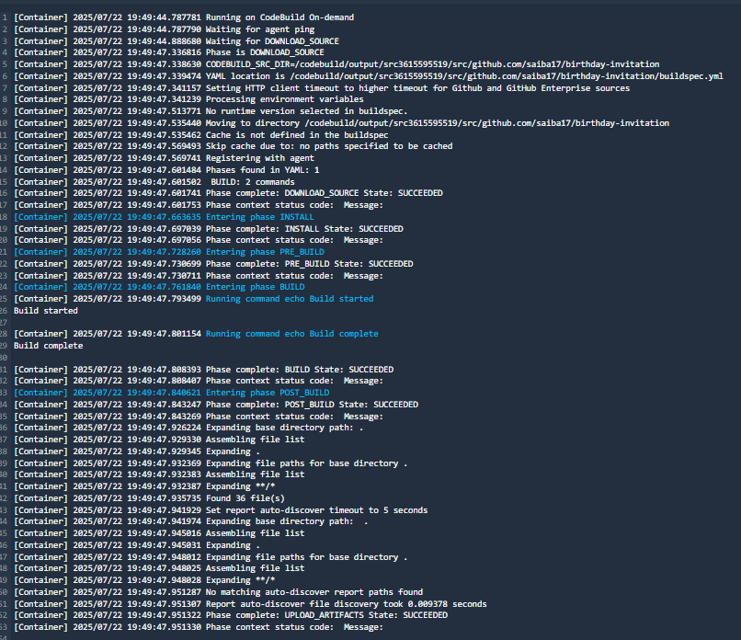

Part D – Create CodePipeline
- Go to CodePipeline → Create Pipeline
• Name: SampleWebAppPipeline
• Service Role: CodePipelineServiceRole
• Artifact Store: Use earlier S3 bucket
- Add Source Stage
• Provider: GitHub
• Repo: sample-web-app
• Branch: main
- Add Build Stage
• Provider: AWS CodeBuild
• Project: SampleWebAppBuild
- (Optional) Add Deploy Stage
• Create deploy bucket:
aws s3 mb s3://my-deploy-bucket
• Enable static website hosting in S3
• Deploy manually or use Lambda
Part E – Test CI/CD Pipeline
- Make Code Changes
echo "<h2>Updated on $(date)</h2>" >> index.html
git add index.html
git commit -m "Update index with timestamp"
git push
- Check Pipeline Execution
• Go to CodePipeline Console
• View execution progress
• Success = All stages green
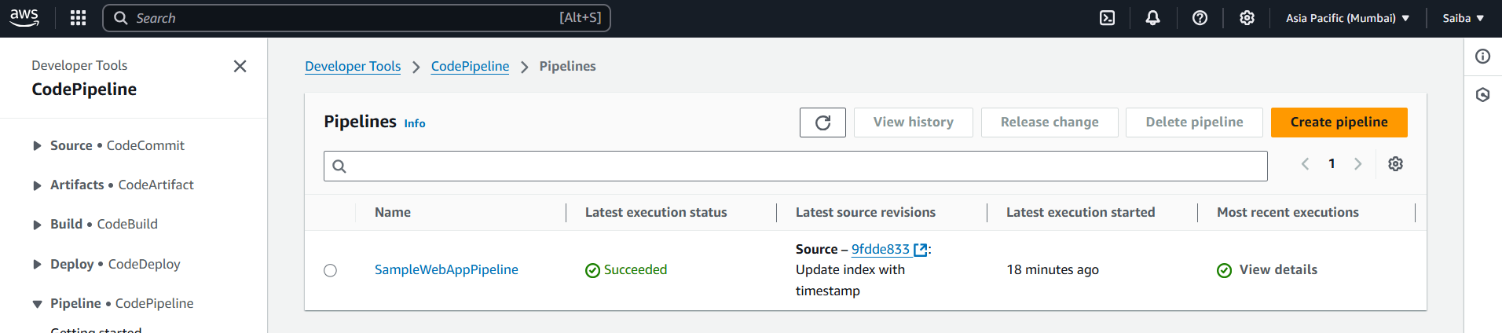
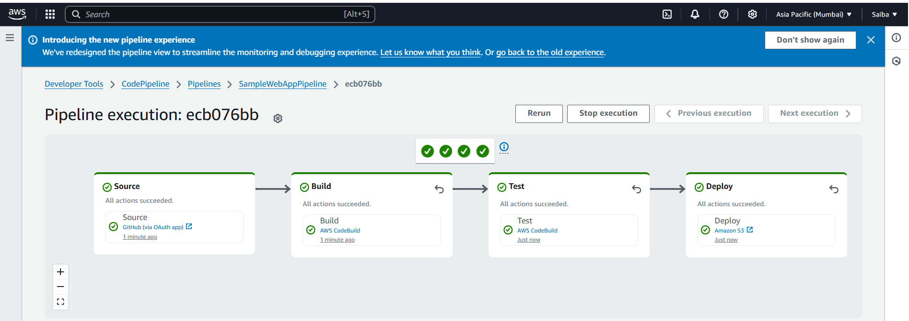

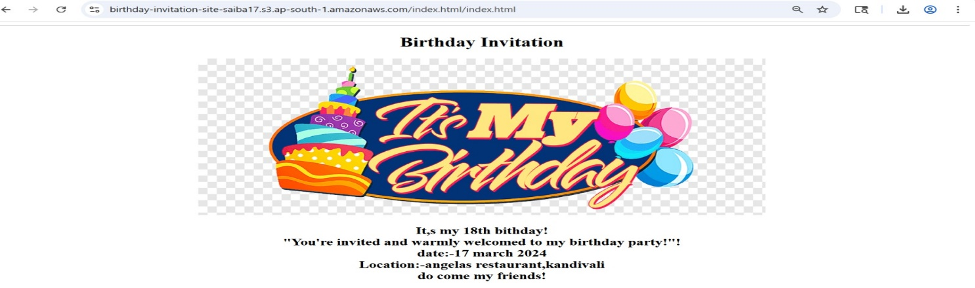

Observations / Challenges
• GitHub PAT may be needed instead of password
• CodeBuild errors? → Check IAM role & buildspec.yml
• S3 hosting not working? → Confirm bucket policy & hosting settings
• Role mismatch? → Verify IAM trust relationships
Instructor Remarks
